**Adding & deleting properties of an object**

JavaScript objects are dynamic in nature (we can **add** and **delete** properties of an object at run time).

**To add new properties to an object we execute the next syntax:**

**Syntax:**

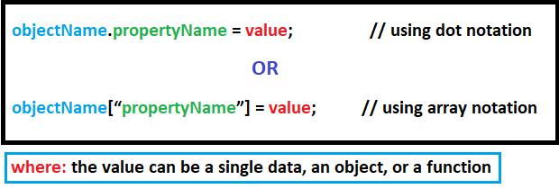

**To delete properties from an object we execute the next syntax:**

**Syntax:**

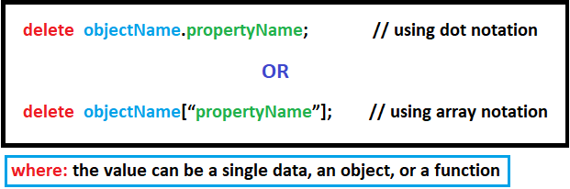

**Examples:**

